**  

### The International Cost Estimating and Analysis Association

### Southern California – San Diego Chapters Joint Workshop

### Workshop Agenda

#### Wednesday, 12 December 2018; Hosted by Leidos

4161 Campus Point Court, Building E, Room E2660, San Diego, CA 92121

**0800-0830** Registration and Badging

**0830-0845** Welcome Announcements, including Election Update Details for upcoming Chapter and ICEAA elections

* + - **Rich Harwin**, President - ICEAA Southern California Chapter
    - **Tom Bosmans**, Vice-President - ICEAA Southern California Chapter: *Welcome to* ***Leidos***

**0845-0930** Keynote Speaker **Marilyn Babick**, Sea Hunter Program Manager: *Sea Hunter – Autonomy at Sea*

**0930-1015** **Nathan Eskue,** Manager, Program Material Control

Northrop Grumman Innovation Systems, Launch Vehicles Division: *A Robot Brain Might Be the Best Forecasting Tool Possible*

**1015-1035** BREAK & GROUP PHOTO

**1035-1120** **Kurt Brunner,** Senior Principal Parametric Cost Estimator, Leidos, Inc: *CER Issues and Solutions*

**1120-1205** **Dr. Sadrul Ula,** Winston Chung Global Energy Center Chair (University of California – Riverside): *Electrical Engineering Evolution*

**1205-1330** LUNCH: Group Order Out & Off-Site Options Available

**1330-1415** **Eric Sick,** Engineering Cost Consultant, Galorath Incorporated: *SEER-Space in the 21st Century*

**1415-1500** **TBD1,** *CEBoK / PRICE Webinar Options*

**1500-1630** Networking & Group Discussion of Future SoCal-SD Joint ICEAA Collaborations *(@ Genesis Kitchen & Drinks, 4242 Campus Point Court, across parking lot)*

**Reminder – Plan Now to Attend the ICEAA National Conference May 14th-17th – Tampa, FL**

**We Encourage You To Carpool ☺**

Please RSVP at iceaaonline.com or to Tom Bosmans at Leidos NLT 01 December 2018

Email to tom.l.bosmans@leidos.com or telephone (949) 689-8874

Sorry, No Electronics (including cell phones, laptops, or tablets) Allowed in the Conference Room

Please Provide: Your Name, Company Affiliation, Location, Phone Number, Citizenship, DOB & E-mail address. Non-US citizens will be permitted at this workshop by providing the following additional information: Passport Number or Green Card Number or both if available. All visitors must present government-issued photo identification (drivers’ license or passport) so that your Visitor Pass can be generated & validated. Please let Tom know if you are an ICEAA member. See Bottom for Virtual Attendance Instructions.

THERE IS NO CHARGE FOR ATTENDING THE WORKSHOP

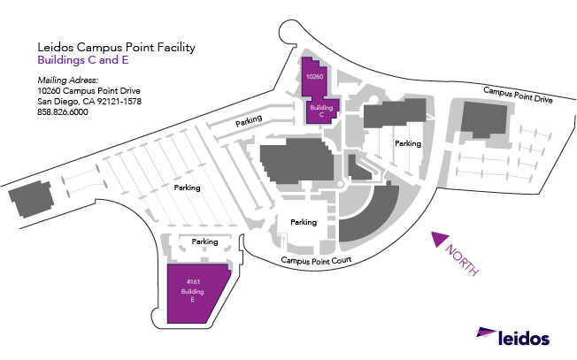

**Add’l**

**Parking**

**Parking**

**Building E**

**From I-5 Heading South**

• Take I-5 South past I-805

• Keep right to take Pacific Coast Highway/I-5 South toward Downtown San Diego.

• Take the Genesee Ave exit (EXIT 29).

• Keep LEFT to take the Genesee Ave E ramp

• Turn LEFT onto Genesee Ave/County Hwy-S21. Continue to follow Genesee Ave.

• Turn LEFT at light onto Campus Point Dr.

• Turn LEFT onto Campus Point Court and drive to end of the street into parking lot.

• Building E is on the left side of the parking lot, 4161 Campus Point Court, Room E2660

**From I-5 Heading North**

• Take I-5 North

• Take the Genesee Ave exit (EXIT 29).

• Take the Genesee Ave East ramp.

• Merge onto Genesee Ave.

• Turn LEFT at light onto Campus Point Dr.

• Turn LEFT onto Campus Point Court and drive to end of the street into parking lot.

• Building E is on the left side of the parking lot, 4161 Campus Point Court, Room E2660

**SoCal December Workshop GoToMeeting Info -** Wed, Dec 12, 2018 7:00 AM - 5:00 PM PST   
  
**You can join our meeting from your computer, tablet or smartphone.**  
<https://global.gotomeeting.com/join/921249141>   
**You can also dial in using your phone.**  
United States: [+1 (312) 757-3119](tel:+13127573119,,921249141)   
**Access Code: 921-249-141**  
Australia: [+61 2 8355 1038](tel:+61283551038,,921249141) / United Kingdom: [+44 330 221 0097](tel:+443302210097,,921249141)   
First GoToMeeting? Let's do a quick system check:   
<https://link.gotomeeting.com/system-check>

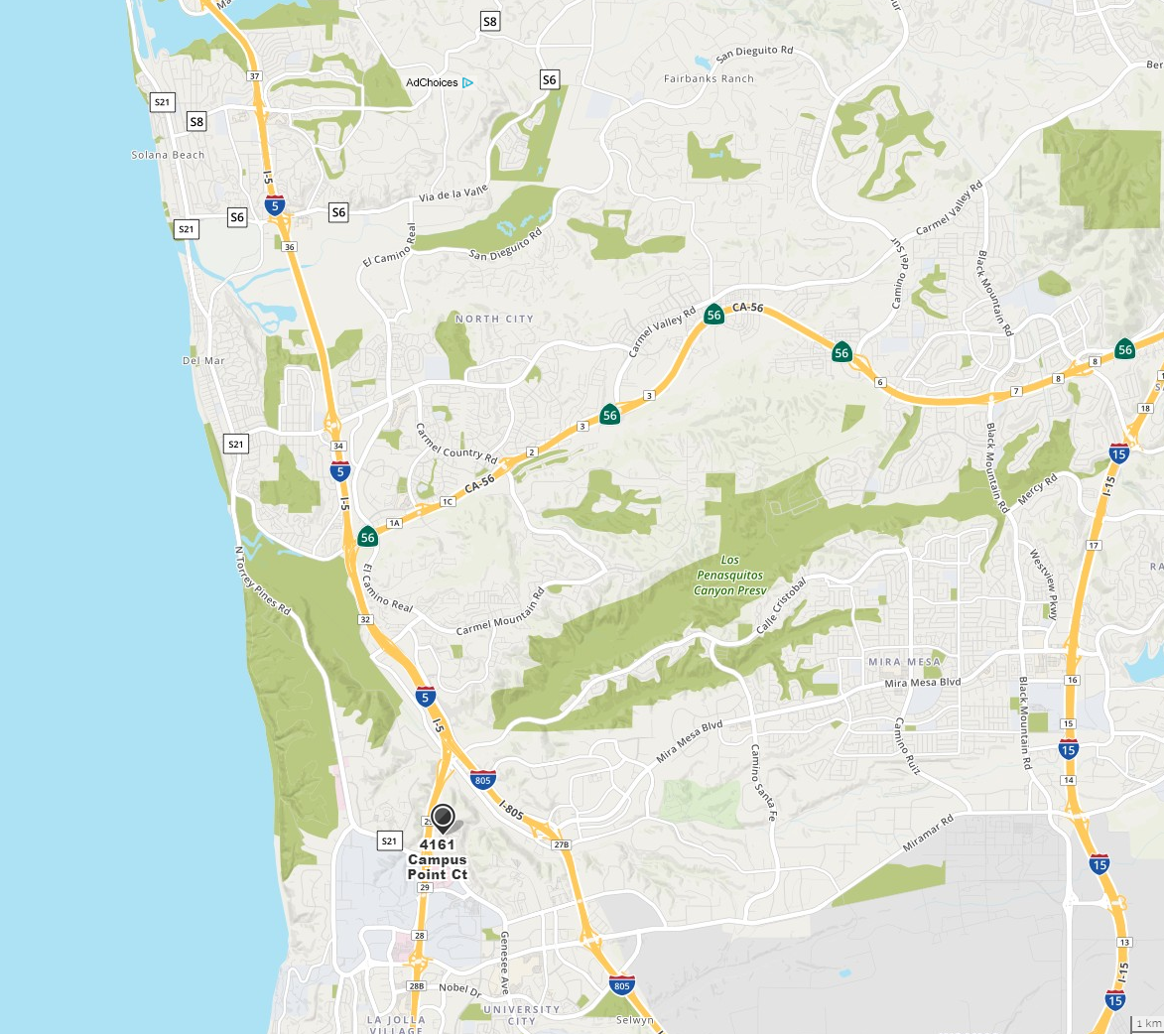

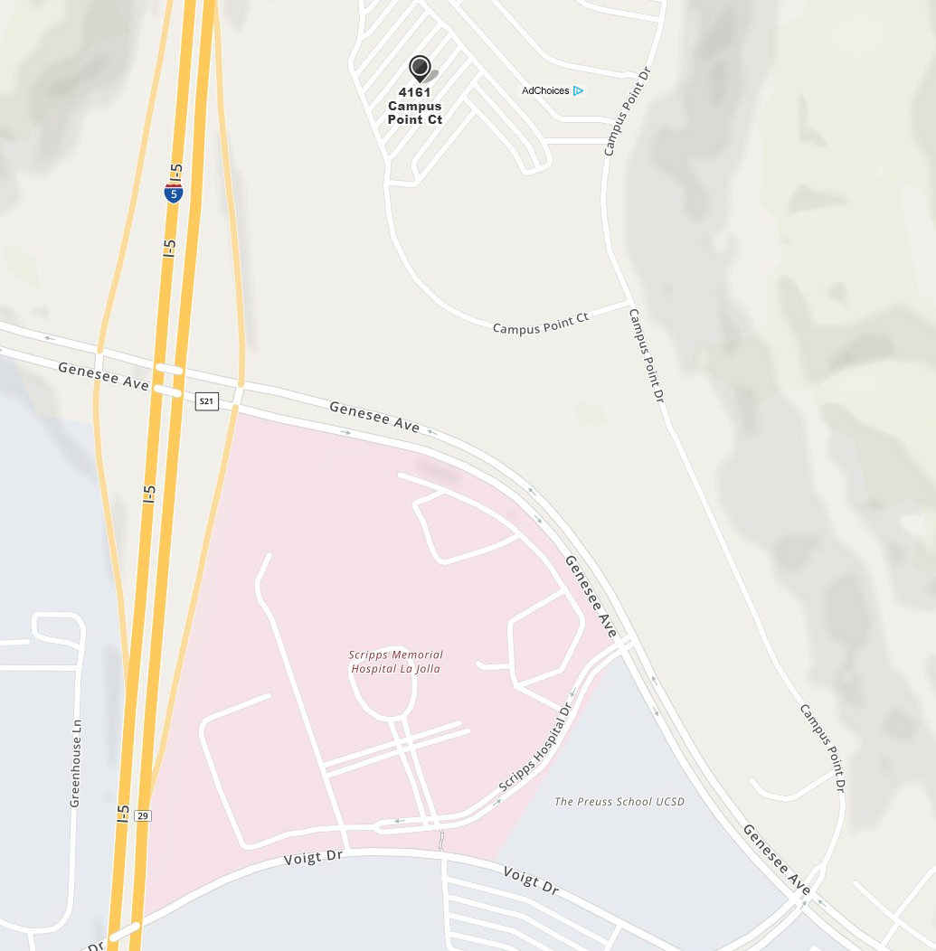

**Hotels Located Closest to**

**Leidos, Campus Point**

**San Diego, California 92121**

**The Lodge at Torrey Pines** - 3.68 miles

11480 North Torrey Pines Road

La Jolla, CA 92037

858-453-4420

**Hilton Torrey Pines** - 2.68 miles

10950 North Torrey Pines Road

La Jolla, CA 92037

858-558-1500

**The Radisson** - 3.28 miles

3299 Holiday Court

La Jolla, CA 92037

858-453-5500

**Hyatt Regency** - 2.73 miles

3777 La Jolla Village Drive

San Diego, CA 92121

858-552-1234

**Marriott Hotel** - 1.87 miles

4240 La Jolla Village Drive

La Jolla, CA 92037

858-587-1414

**Embassy Suites** - 1.77 miles

4550 La Jolla Village Drive

San Diego, CA 92122

858-453-0400

**SoCal December Workshop**  
Wed, Dec 12, 2018 7:00 AM - 5:00 PM PST   
  
**Please join my meeting from your computer, tablet or smartphone.**  
<https://global.gotomeeting.com/join/921249141>   
  
**You can also dial in using your phone.**  
United States: [+1 (312) 757-3119](tel:+13127573119,,921249141)   
  
**Access Code: 921-249-141**  
  
**More phone numbers**  
Australia: [+61 2 8355 1038](tel:+61283551038,,921249141)   
United Kingdom: [+44 330 221 0097](tel:+443302210097,,921249141)   
  
First GoToMeeting? Let's do a quick system check:   
<https://link.gotomeeting.com/system-check>

**Restaurants located within 5 miles of Leidos, Campus Point**

**San Diego, California 92121**

**Apollonia Greek Bistro**

http://www.apolloniabistro.com/

858 455 1535

8650 Genesse Ave Ste 106

San Diego, CA 92122

**BJ’s Brewhouse**

http://www.bjsrestaurants.com/locations/ca/la-jolla

858-257-3640

8785 Villa La Jolla Drive

La Jolla, CA 92037

**California Pizza Kitchen**

http://www.cpk.com

858-457-4222

3363 Nobel Drive

La Jolla, CA 92037

**Chick-fil-A**

<https://www.chick-fil-a.com>

858-450-4417

9370 Scranton Rd

San Diego, CA 92121

**Chili’s**

<https://www.chilis.com>

858-457-5962

5969 Lusk Blvd

San Diego, CA 92121

**Chipotle**

http://www.chipotle.com/en-US/Default.aspx?type=default

858-999-2403

8750 Genesee Ave

San Diego, CA 92122

**Draft Republic**

http://www.cohnrestaurants.com/menu-restaurants/draftrepublic

(858) 450-1400

4282 Esplanade Court

San Diego, CA 92122

(858) 450-1400

**Din Tai Fung**

<https://dintaifungusa.com>

858-375-5988

4301 La Jolla Village Dr, Unit 2000

San Diego, CA 92121

**Five Guys Burgers and Fries**

http://www.fiveguys.com/

858-658-0778

8650 Genesee Ave, Ste 242

San Diego, CA 92122

**Genesis Kitchen + Drinks**

<http://www.genesiskitchenanddrinks.com/>

858-230-7001

4242 Campus Point Ct

San Diego, CA 92121

**Green Acres**

https://greenacresd.com/campus-pointe/

858-450-9907

10300 Campus Point Drive

San Diego, CA 92121

**Harry’s Bar and American Grill**

http://harrysbarandamericangrill.com/

858-373-1252

4370 La Jolla Village Drive #150

San Diego, CA 92122

**Islands Fine Burgers and Drinks**

http://www.islandsrestaurants.com

858-455-9945

La Jolla Village Square

3351 Nobel Drive

La Jolla, CA 92037

**Karl Strauss Brewing Company**

<https://www.karlstrauss.com>

858-587-2739

9675 Scranton Rd

San Diego, CA 92121

**Ki Sushi & Sake Bar**

http://www.kisushibar.com/

858-404-0707

8650 Genesee Ave, Ste 105

San Diego, CA 92122

**L&L Hawaiian Barbecue**

https://www.hawaiianbarbecue.com

858-554-0888

4150 Regents Park Row, Unit 187

La Jolla, CA 92037

**Leucadia Pizzeria & Italian Restaurant**

http://www.leucadiapizza.com/

858-597-2222

7748 Regents Road

San Diego, CA 92122

**McDonald’s**

(858) 452-3014

8650 Genesee Ave

San Diego, CA 92122

**P.F. Chang’s**

http://www.pfchangs.com

858-458-9007

4540 La Jolla Village Drive

San Diego, CA 92122

**Pho La Jolla**

[www.pholajolla.com](http://www.pholajolla.com)

858-587-4688

3211 Holiday Ct, Unit 102

La Jolla, CA 92037

**Regents Pizzeria**

<https://www.regentspizza.com>

858-550-0406

4150 Regents Park Row, Unit 100

La Jolla, CA 92037

Red O Taste of Mexico

http://www.redorestaurant.com/

858-291-8360

4340 La Jolla Village Dr

San Diego, CA 92122

**Red Robin**

<https://www.redrobin.com>

858-450-0343

4373 La Jolla Village Dr

San Diego, CA 92122

**Rock Bottom Restaurant & Brewery**

http://www.rockbottom.com/la-jolla

858-450-9277

8980 Villa La Jolla Drive

La Jolla, CA 92037

**Roy’s Hawaiian Fusion Cuisine**

http://www.roysrestaurant.com

858-455-1616

[8670 Genesee Avenue  
San Diego, CA 92122](http://roys.Know-Where.com/roys/cgi/site?site=ROY20&address=)

**Rubicon Deli**

<https://rubicondeli.com>

858-877-9911

4130 La Jolla Village Dr, Unit 104

La Jolla, CA 92037

**Sammy's Woodfired Pizza**

http://www.sammyspizza.com

858-404-9898

8650 Genesse Ave

San Diego, CA 92122

**Subway**

http://www.subway.com/subwayroot/default.aspx

858-678-0129

8650 Genesee Ave, Ste 236

San Diego, CA 92122

**Sweetfin Poke**

<https://www.weetfin.com>

858-251-4840

4301 La Jolla Village Dr, Unit 2035

San Diego, CA 92122

**The Flame Broiler**

<https://flamebroilerusa.com>

858-458-9941

9450 Scranton Rd, Unit 115

San Diego, CA 92121

**Which Wich**

<https://www.whichwich.com>

858-558-8434

9430 Scranton Rd, Unit 104

San Diego, CA 92121

**Westfield UTC Mall Restaurants**

* Corner Bakery Café

858-453-1333

* Boudin Sourdough Bakery & Café

858-453-1849

* Eureka! Discovery American Craft

858-210-3444

* Lemonade

858-251-0912

* Napizza

858-230-7533

* Queenstown Bistro

858-623-2748

* Red Robin Gourmet Burgers

858-450-0343

* Seasons 52

858-450-1252

* Shake Shack

619-391-1571

* Smokeyard BBQ & Chop Shop

858-630-7427

* The Winery Restaurant and Wine Bar

858-458-0031

858-630-7427

* True Food Kitchen

858-431-4384

* Veggie Grill

858-458-0031

**Westfield Mall UTC Food Court**

4545 La Jolla Village Drive

San Diego, CA 92122

* Bibigo
* Charley’s Philly Steaks
* Craft Pizza
* Kazanori Poke & Wraps
* Kebab Grill
* Khan’s Mongolian BBQ
* Johnny Rockets
* MonGrill
* Noodles & Company
* Panda Express
* Pholicious
* Royal India
* Rubios
* Ruby Thai
* Sarku Japan
* Simon’s Burgers
* Tender Greens